**Smart India hackathon-2018**

**After Death Care**

**(**An application developed to provide mortuary vans for after death services.)

**Ministry:**Ministry of Health & Family Welfare **Problem Code:**#MHF9

**Priority**: high

**Authors:**

|  |  |
| --- | --- |
| **NAME** | **E-mail ID** |
| Prathamesh Dixit | prathmeshydixit@gmail.com |
| Parshuram Reddy Sudda | parshuram.sudda@gmail.com |
| Vishnu Vardhan Reddy Rapuru | vishnurapuru10@gmail.com |
| Konduri Monika | kondurimonika@gmail.com |
| Buddiga Sai Divya Praneetha | divyapranee@gmail.com |
| Vaishnavi Yasala | yasalavaishnavi01@gmail.com |

**Problem:**

**Mortuary Vans are largely not available across states and it becomes extremely disappointing if the vans are not available to take dead bodies from hospitals to their respective homes. Though there are vans which are available in private space however there is no single point of contact through which services of these vans could be requested when in need. Hence it is of dire need to develop an application which can act as a common platform for the people who need the services of mortuary vans during the emergency as well as the mortuary van owners to have a common platform where it will be easy and also feasible for both the parties to contact**

**Introduction:**

In a country like India which has huge numbers of population it is very difficult to manage the amounts of dead bodies in the government as well as the private hospitals with so many number of people having last breaths here.

It becomes a very hectic task of managing the dead bodies in the country. With so many numbers of such bodies it gives an obvious rise to problems such as lack of space in mortgages to store bodies, non easy identification of bodies and may even leadto very serious problems such as organ trafficking, bodies getting rotten and may and many more such problems.

Hence there is need to understand that an immediate solution is to be presented to this

Problem and is done by our team by presenting an application which will give a direct point of contact for both the service seekers and the providers. The following project can be divided as given;

**Interface for the users**:

It includes a simple interface which will be required for the people who want to contact the vans for services.

It includes the designing of application with simple and user understandable interface which may not hinder the user during the time of emergency. The app is also provided with the features of use of multiple Indian languages so that the people hailing from rural and lesser literate part of the society can have an access to it.

**Interface with SHG’s:**

The application will also have access allowed for the Self help groups as well as the NGO’s where in the identification and help to the corpse’s family will be quick and easy.

**Interface with authorities:**

1. The interface will have feeds queries and help requests sent to them by the users.
2. When the request regarding the mortuary vans is placed the authorities will have an authentication check and will be able to respond to the query.
3. For this the government should initiate a few tie ups with the private hospitals as well as the NGO copse vans.
4. A very convenient use of the Google maps can be done by inheriting the Google APIs wherein the closest availability of a van and live tracking of vans can be done by both users and the authorities.
5. For financially backward people, the government can bear the cost or can give a relief on the expense by linking their adhar card (UIDs) with the details of corpse’s tracking.
6. For people hailing from a very remote location, a centralized helpline will be generated.

**Technology stack:**

**App development**: Android Development Studio 3.1.0

**Programming interface**: Java jdk 1.8.0

**Server and database management**: Google firebase v 11.0.1

An android phone with a minimum of 1GB RAM and android version 4.4(API 20) or above.

**UML diagram and case study:**

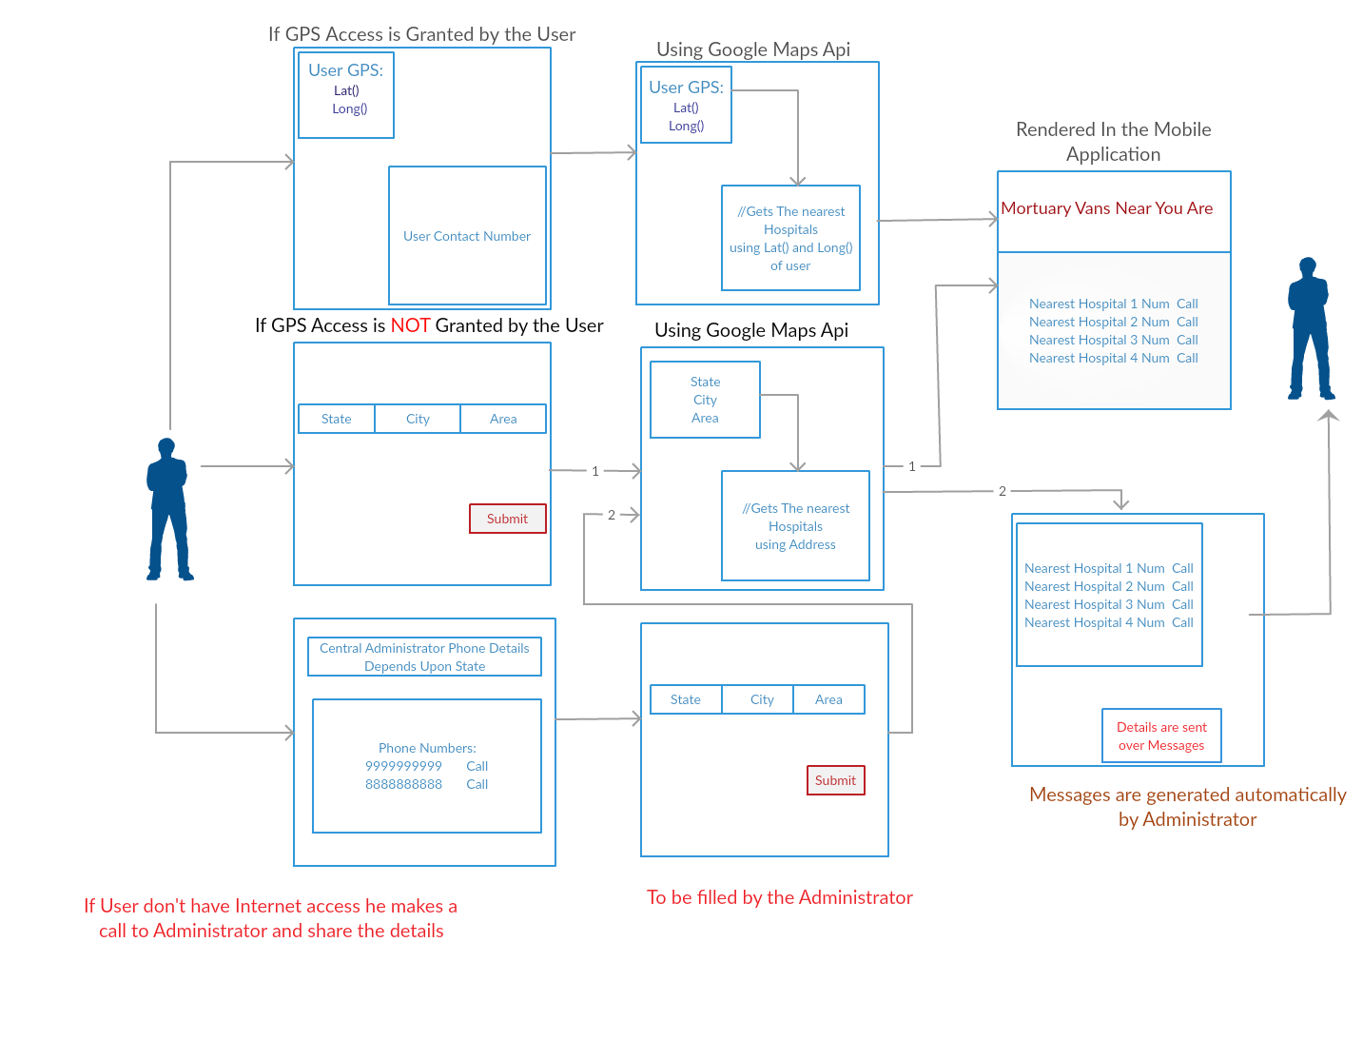

**Pseudo code:**

Step 1: App Automatically Checks for GPS permissions.

Step 2: If user has granted Access permissions towards GPS then Lat(),Long() are posted through http to Google Api.

Step 3 : It is then resolved through api and nearest locations of Hospitals are located by Google api .

Step 4: Then it is Received by the app and shown to the user.

Step 5: If user has denied the permissions of GPS then user is allowed to enter the location details manually

Step 6 : Then is sent to Google api and the step 3 and step 4 Is repeated.

Step 7 : If user don’t have app or location then he can call to the central number provided by the Government of India

Step 8: By using Location provided by the user administrator send the details and then reply is sent to the user apps using messaging api

Step 9: user receives the numbers and then calls to the nearest hospital for the mortuary van

**Advantages:**

* The application developed will help cause of many who are in an urgent need of the van.
* It will help serve the people even in the remote and the backward areas.
* The tracking of exact number of vans available for service can be made both by the government and private hospital managements.
* There will be a definite count of the service provided basing on which the authority can decide the increment or decrement in services.
* The authentication process will help to allow service only to genuine users.

**Dependencies:**

* Help will be needed from the government and also self help groups to establish tie ups with private mortuary van owners so that more number of vans are involved in the service.
* The mortuary van drivers should posses a valid authentication card so that only genuine drivers are selected and also people can’t misuse the services by faking to be the driver.
* The government is also expected to make good amount of publicity and also make the people from even the remote parts of our nation to have a basic knowledge about the service and the centralized number.
* Free services can be provided for people belonging to the underprivileged part of society.